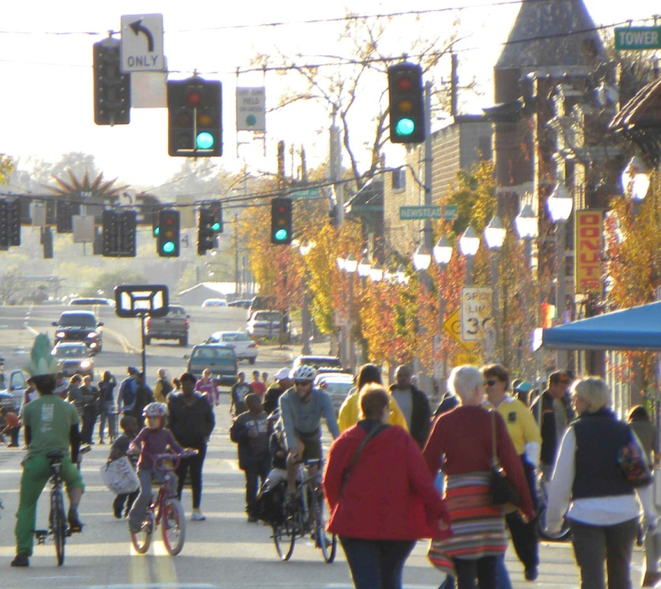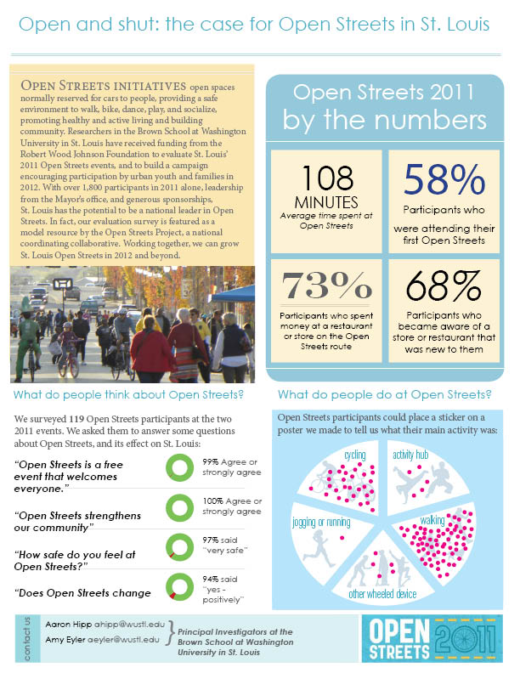

Open and Shut: the Case for Open Streets in **[location]**

OPEN STREETS INITIATIVES open spaces normally reserved for cars to people, providing a safe environment to walk, bike, dance, play, and socialize, promoting healthy and active living and building community. Lorem ipsum dolor sit amet, consectetuer adipiscing elit, sed diam nonummy nibh euismod tincidunt ut laoreet dolore magna aliquam erat volutpat. Ut wisi enim ad minim veniam, quis nostrud exerci tation ullamcorper suscipit lobortis nisl ut aliquip ex ea commodo consequat. Duis autem vel eum iriure dolor in hendrerit in vulputate velit esse molestie consequat, vel illum dolore eu feugiat nulla facilisis at vero eros et accumsan et iusto odio dignissim qui blandit praesent luptatum zzril delenit augue duis dolore te feugait nulla facilisi.

**What do people think of Open Streets?**

We surveyed **###** Open Streets participants at the **[YEAR]** events. We asked them to answer some questions about Open Streets, and its effect on **[CITY}**:

***“Open Streets is a free event that welcomes everyone.”***

***“Open Streets strengthens our***

***community”***

***“How safe do you feel at Open Streets?”***

***“Does Open Streets change your feelings about the city?”***

**XX%** Agree or strongly agree

**XX%** Agree or strongly agree

**XX%** said   
“very safe”

**XX%** said   
“yes - positively”

Open Streets **[YEAR]**

by the numbers

XX

Minutes

*Average time spent at Open Streets*

XX%

*Participants who were attending their first*

*Open Streets*

XX%

*Participants who spent money at*

*a restaurant*

*or store on the*

*Open Streets route*

XX%

*Participants who became aware*

*of a store or*

*restaurant that was new to them*

**What do people do at Open Streets?**

**Contact Us**

**CONTACT EMAIL ADDRESSES**

**CONTACT EMAIL ADDRESSES**



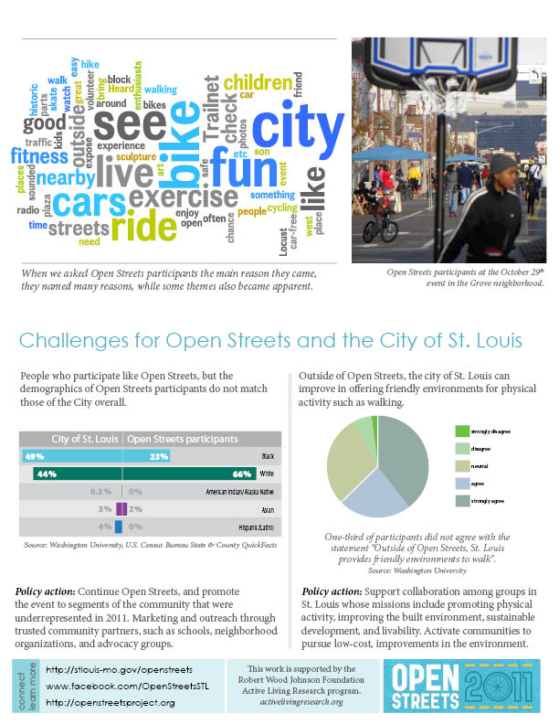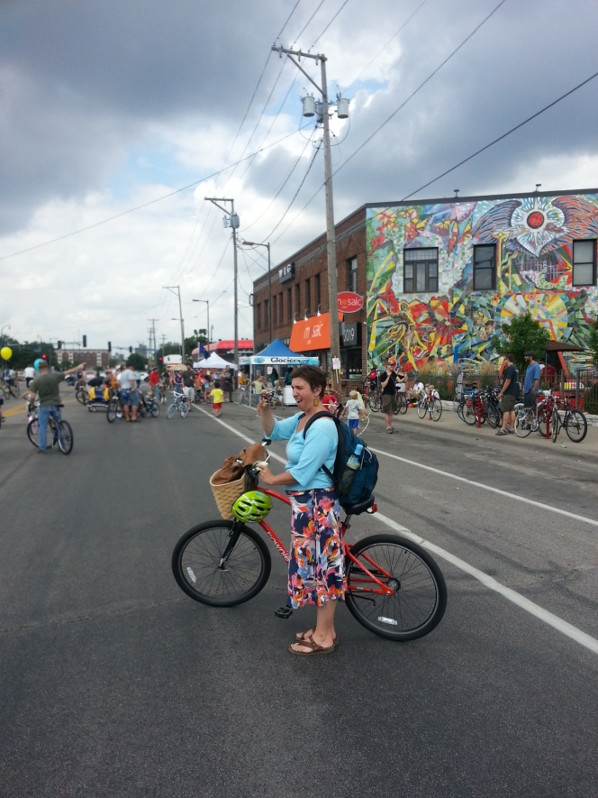

***Policy action:*** Support collaboration among groups in [CITY] whose missions include promoting

physical activity, improving the built environment, sustainable development, and livability. Activate

communities to pursue low-cost, improvements in the environment.

***Example event picture. List event and date for caption.***

**Connect & Learn More**

**EVENT WEBSITE**

**FACEBOOK PAGE**

http://openstreetsproject.org

**Challenges for Open Streets and the City of [NAME]**

***Policy action:*** Continue Open Streets, and promote the event to segments of the community that were

underrepresented in [YEAR]. Marketing and

outreach through trusted community partners, such as schools, neighborhood organizations, and

advocacy groups.

People who participate like Open Streets, but the demographics of Open Streets participants do not match those of the City overall.

Outside of Open Streets, the city of St. Louis can improve in offering friendly environments for physical activity such as walking.

**A template of this policy brief is also available in Microsoft Publisher (to help with formatting). You may request the Publisher file by emailing** [**alr@ucsd.edu**](mailto:alr@ucsd.edu)**.**