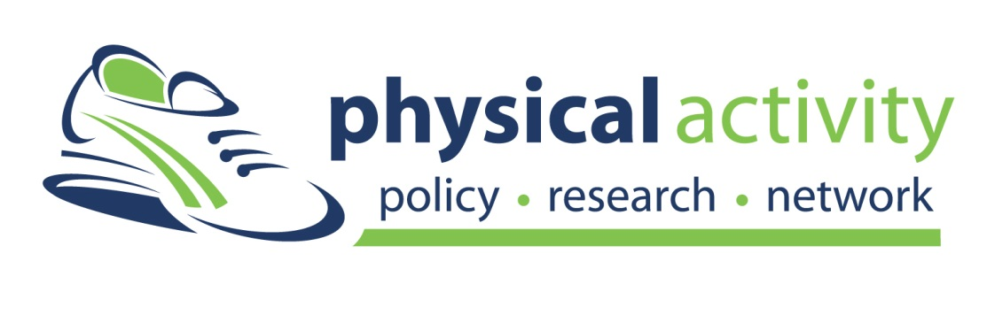
Physical Activity Plan
A GUIDE TO CREATING A PHYSICAL ACTIVITY PLAN FOR YOUR COMMUNITY
Template

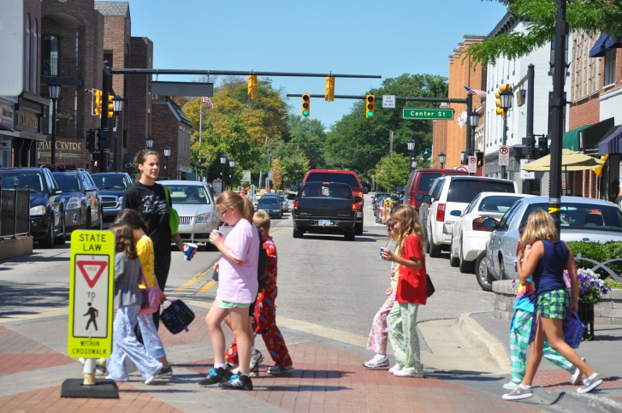
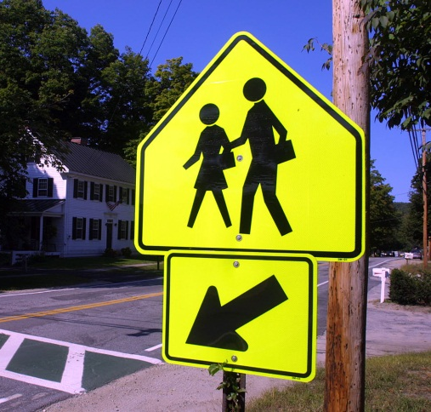

Introduction
Now that you have formed a coalition, assessed your community, written objectives, decided on interventions and created an evaluation plan, it is time to write the physical activity plan. The following pages contain a template designed to facilitate the writing process by using the information gathered in steps 1-5 detailed in the separate document titled Physical Activity Plan Toolkit: A Guide to Creating a Physical Activity Plan for Your Community.

HOW TO USE THIS TEMPLATE
This template can, and should, be altered to meet the needs of your community. The written content as well as the formatting and design are intended to be modified to reflect your community’s mission and vision. All of the fill-in-the-blank areas, directions or examples are shown in red font and brackets [ ] in order to facilitate easier adaptation and to help make it clear that these areas need to be filled in or removed before the report is published. Furthermore, it is likely that many coalitions will not feel it is within their scope to address each one of the eight areas targeted by the National Physical Activity Plan; again, coalitions can broaden or focus their scope of work to meet the needs of their community.

One key point that we would like to stress is to keep your audience in mind while writing the plan. This should influence the layout, length, and language that your plan employs. The layout that we suggest using for your plan is as follows:

- Cover page
- Acknowledgements
- Table of Contents
- Mission and Vision
- Executive Summary - *write this summary after completing the plan
- Introduction
- Interventions, Objectives and Evaluations
- Engaging communities in implementation
- References
- Appendices

Section 1: Cover Page with Graphic
[Create a visually appealing cover page with photos and graphics – see examples from Hawaii, Idaho, and Indiana below]
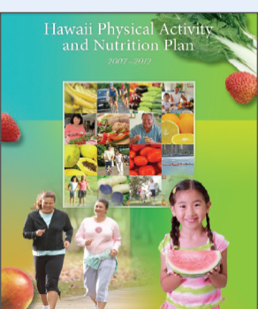
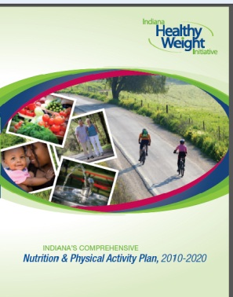

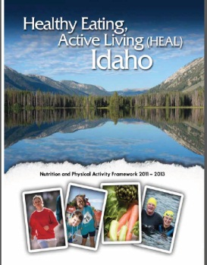

Hawaii: http://www.healthyhawaii.com/images/stories/PANSummit/pan%20plan%20final.pdf
Idaho: http://www.healthandwelfare.idaho.gov/Portals/0/Health/IPAN/IPAN_State_Plan.pdf
Indiana: http://www.inhealthyweight.org/files/IN_State_Obesity_Plan_2010-2020.pdf
Section 2: Acknowledgements
The [state/community] Physical Activity Plan was made possible because of the leadership of the following organizations [list here] and tireless work from these individuals [list here]. We are grateful to have had representatives from a variety of sectors, including [list sectors involved, for example -transportation, policy, education, health, business, and parks and recreation] on our board of advisors.
Coalition Members
The plan development committee is headed by [ ]. Without their input, the plan would not have been developed.

Funding
This [state/community] plan was funded through the generous donation of [organization/individual/grant].

Special Acknowledgements
We would like to acknowledge the input of [individuals/organizations, etc.,]. We are very grateful for the time and energy they have devoted to making the lives of our citizens healthier and more active.

Section 3: Table of Contents
[Update the page numbers to fit your document]
Mission and Vision 5
Executive Summary 6
INTRODUCTION 8
strategies, objectives and evaluation 12
Business and Industry 12
Education 16
Health Care 19
Mass Media 22
Non-Profit and Volunteer 24
Parks, Recreation, Fitness and Sports 27
Public Health 30
Transportation, Land Use and Community Design 34

engaging communities in implementation 38
REFERENCES 40
APPENDICES 42

Section 4: Mission and Vision

Mission
The mission of [state/community] is

Vision
The vision of [state/community] is

Section 5: Executive Summary
Overview

According to the Centers for Disease Control and Prevention (CDC), there are many benefits of physical activity. Physical benefits include weight control, and a reduction of the risks for cardiovascular diseases, type 2 diabetes, osteoporosis and some cancers. Physical activity also helps build muscle and strengthen bones. Mental benefits include an improvement in mental health and mood. Furthermore, regular physical activity increases the chances of having a longer life.¹

Sedentary behavior, regardless of physical activity, is also linked with a significant increase in the risk of type 2 diabetes as well as obesity. Therefore, it is not enough to avoid physical inactivity, but to simultaneously limit sedentary behavior.²

The National Physical Activity Plan (NPAP) was launched in 2010 to help increase physical activity in the population. The vision of the plan is that “One day, all Americans will be physically active and they will live, work, and play in environments that facilitate regular physical activity.” The NPAP provides recommendations for eight societal sectors: Business and Industry, Education, Health Care, Mass Media, Parks Recreation Fitness and Sports, Public Health, Transportation Land Use and Community Design, and Volunteer and Non-Profit.³ As such, the recommendations listed in [state/community] Physical Activity Plan also focus on these key areas. It is our vision that [state/community] will meet or exceed national physical activity recommendations, improving the quality of life for its residents.

The target audience for the [state/community] physical activity plan includes policy and decision makers, physical activity practitioners, and other physical activity advocates.

Priority Areas

There are five priority areas (or strategies) for [state/community]. These include [fill in your priority areas below]

[For example, the West Virginia Executive Summary discusses their five priorities of their physical activity plan in detail. These priority areas include school-based programs and initiatives, public awareness and social marketing, community engagement and environment, institutional and organizational support, and policy].⁴

These priority areas have been selected after various meetings with a variety of stakeholders, including representatives from multiple sectors and from every region of [state/community]. [Describe process of data collection].

Key Recommendations
In order to achieve success in these priority areas, the following recommendations need to be considered:

[List recommendations]

[Insert a picture of your coalition/team here]

Section 6: Introduction

Overview
This physical activity plan follows the same order as the recommended intervention areas in the National Physical Activity Plan. These areas include:
- Business and Industry
- Education
- Health Care
- Mass Media
- Parks, Recreation, Fitness and Sports
- Public Health
- Transportation, Land Use and Community Design
- Volunteer and Non-Profit
Each area in this guide will include an assessment of what is currently being done in the area, as well as proposed interventions. Most importantly, specific, measurable, time-based objectives are included for each intervention, as well as the organization(s) which will assume responsibility for their completion.
Finally, strategies to encourage community participation in physical activity implementation are outlined. Community participation is vital to any physical activity intervention that wishes to be sustained into future generations, as it converts participants into stakeholders.

State and National Data

The CDC estimates that nationally only 48% of adults meet the national guidelines for physical activity. Furthermore, less than 3 out of 10 high school students participate in 60 minutes of physical activity daily. Disparities exist between different populations and age groups. More non-Hispanic white adults meet the 2008 Physical Activity Guidelines for aerobic and muscle-strengthening activity than non-Hispanic black adults and Hispanic adults. Men are more likely than women to meet the guidelines for aerobic activity, and younger adults are more likely to meet the aerobic activity guidelines than older adults. Adults with more education are more likely than those with less education to meet the guidelines, and adults whose family income is above the poverty level are more likely to meet the guidelines than adults whose family income is at or below the federal poverty level.⁵

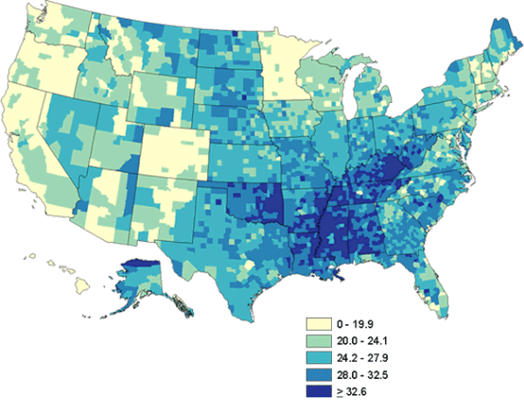
2008 Age-Adjusted Estimates of the Percentage of Adults Who Are Physically Inactive ⁵

As the map indicates, [state] compares [favorably/unfavorably] with regards to physical activity nationwide. According to the Behavioral Risk Factor Surveillance System, the prevalence of physical activity participation in the last month was [insert information from the following website http://apps.nccd.cdc.gov/brfss/list.asp?cat=EX&yr=2010&qkey=4347&state=All] . The prevalence of meeting the Healthy People 2010 objectives in [state] was [insert statistic from http://apps.nccd.cdc.gov/pasurveillance/statesumv.asp ].

Social Ecological Model of Behavior Change
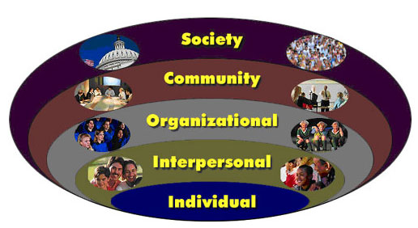
This data indicates a clear need for physical activity interventions, from policies to communities to individuals. Because physical activity does rely on both external, environmental factors as well as internal influences, we use the Social Ecological Model for Behavior Change to describe the process necessary to facilitate physical activity in [state/community].
Individuals: Addressing physical inactivity implies changing everyday behaviors. This means changing knowledge, attitudes and beliefs. This doesn’t happen alone: formal and informal social networks often provide the motivation needed to engage in physical activity.
Interpersonal: Spouses, friends, family, peers, and coworkers represent potential sources of interpersonal influences. Interpersonal groups can facilitate individual behavior change by giving support and guidance to start making healthy lifestyle changes.
Organizations: Schools, workplaces, volunteer networks—these all have the capacity to help individuals make physical activity a part of their day through policy changes and promotion of healthy individual behaviors.
Communities: A community is essentially a large organization and consists of groups, residents and organizations that can work together to implement physical activity friendly changes to the area. For instance, communities can impact the connectedness and design of an area by designing parks, passing complete streets policies, or building trails.
Society: Society reflects how all other components work together to create change. Policies and legislation supporting physical activity on a large scale helps individual, interpersonal, organizational, and community-wide programs to function successfully.⁶
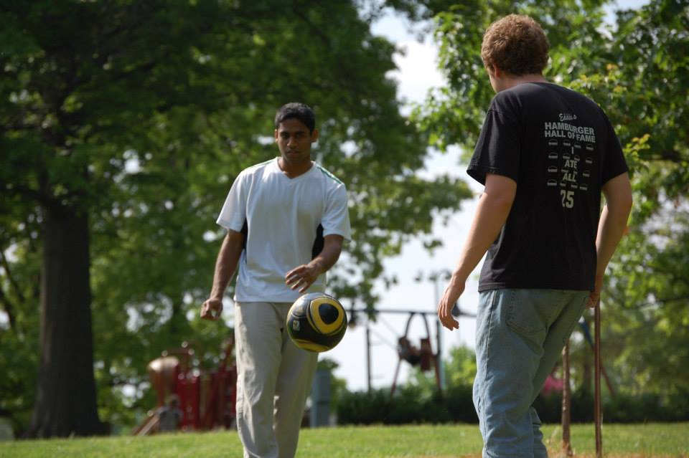
The following chapters contain interventions which will try to encourage physical activity on all levels; the responsibility of being physically active falls as much on society and the environment as it does on the individual. This guide strives to show how each component of [community/state] society can work towards a more active population.
Manteiga, Alicia Active Men, 2013

Section 7: Interventions, Objectives and Evaluations

Business and Industry
The current trend in the workplace is that with the rise in technology, physical activity on the job has decreased. The consequences of a sedentary workday are many, including an increase in the likelihood of health problems. Money is then lost through decreased productivity, absenteeism, and health care costs.
Businesses are in a unique position given their proximity to employees. Simple policy changes or incentives can go a long way in improving employee physical activity both on and off the job.
INDUSTRY SPOTLIGHT
[Insert an example here of a business in your jurisdiction which has shown an interest in the health of its employees or of an intervention at a worksite which is promising or has shown positive results.]
[Refer to page 18 of the Guide for an example]

The National Physical Activity Plan (NPAP) has several strategies and tactics to incorporate business and industry into a national movement towards more physical activity. Our [state/organization] will adopt some of these as guidelines for our specific objectives and activities.
One such strategy is to encourage business and industry to interact with all other sectors to identify opportunities to promote physical activity within the workplace and throughout society. In order to accomplish this, we will identify exemplary cross-sector partnerships for promoting physical activity within the workplace, and disseminate this information to encourage replication.⁷
Involving business and industry in efforts to boost physical activity naturally leads to increased employee and employer participation in worksite programs. In order to effectively monitor the number of participants in such programs, we first need to assess the current number of worksite wellness programs. Following the assessment stage, an increase in participating institutions and members will be pursued.
In order to effectively measure worksite wellness plans, we will use the following definition, adapted from Healthy People 2010. To qualify as a worksite wellness plan, a plan must contain these five program elements: ⁸
- Health education, which focuses on skill development and lifestyle behavior change along with information dissemination and awareness building.
- Supportive social and physical environments. These include an organization’s expectations regarding healthy behaviors, and implementation of policies that promote health and reduce risk of disease.
- Integration of the worksite program into the organization’s structure.
- Linkage to related programs like Employee Assistance Programs (EAPs) and programs to help employees balance work and family.
- Worksite screening programs ideally linked to medical care to ensure follow-up and appropriate treatment as necessary.

OBJECTIVE 1: By [date], [person/organization responsible] will have identified one local business which has established a cross-sector partnership for improving physical activity within the workplace.
By [date], [person/organization] will have disseminated these best practices to [number] of local businesses via [list ways: may include newsletters, Tweets, Facebook posts, conversation, emails, etc.].
Activity/Strategies | Partners | Time | Cost | Indicator
Determine one business involved in cross-sector partnership for improving PA within workplace. | [WHO will be responsible?] | [During what period?] | [How MUCH can you spend on this?] | [Name of business].
Determine best practices that the local business uses. |  |  |  | [Report of best practices].
Determine the best way to disseminate these practices to other businesses |  |  |  | [Number of methods].
Disseminate these practices to other businesses. |  |  |  | [Number of businesses reached by dissemination efforts]
Evaluate: Was the dissemination technique successful? Did any businesses change wellness practices as a result? |  |  |  | [Number of businesses changing or altering wellness practices as a result of dissemination].

OBJECTIVE 2: By [date], [person/organization] will have identified the number of participating employers and employees in worksite wellness programs within [geographic scope of plan]. The number of participating employers will increase by [%] within the following two years.
Activity/Strategies | Partners | Time | Cost | Indicator
Determine methodology and develop/determine best assessment tool | [WHO will be responsible?] | [By WHEN will this be accomplished?] | [How MUCH can you spend on this?] | Methodology and tool determined
Conduct assessment of community/state |  |  |  | Findings on employers/ employees
Issue findings, disseminate to businesses and policymakers |  |  |  | Report of findings
Discuss incentives of wellness programs with employers |  |  |  | # businesses reached
Evaluate: How many new employers have worksite wellness programs as a result of the intervention? |  |  |  | # new businesses with worksite wellness programs

Education
In the US, around 45 million students are enrolled in elementary and secondary schools.⁹ On average, these students spend around 1,300 hours per year in school.¹⁰ Because of increasing pressure on academic achievement paired with the constant threat of budget cuts, programs involving physical activity within schools are often short-changed.

Spotlight on Education: [Insert your intervention here].

[Insert information regarding a program, policy, or intervention which has worked in your community or state. For example, a Safe Routes to School program, an extended day program encouraging physical activity, or a teacher training session which demonstrates techniques incorporating physical activity into normal classroom exercises would be appropriate.
Refer to pg. 16 of the Guide for an example]
Research indicates that physical activity improves academic performance. Teachers, coaches, administrators, and district officials should all take a leadership role in increasing the physical activity levels of their students. Fortunately, there are many evidence-based interventions which focus on increasing physical activity within the realm of education. Some of the tactics and strategies from the National Physical Activity Plan (NPAP) include the following:
- Provide access to and opportunities for high-quality, comprehensive physical activity programs, anchored by physical education, in pre-kindergarten through grade 12 educational settings.
- Provide access to and opportunities for physical activity before and after school.¹⁰
Related to these strategies are the World Health Organization’s intervention recommendations for physical activity. After reviewing the published information available, they conclude that physical activity is increased in schools when the following criteria are met:
- Physical activity curriculum is taught by trained teachers,
- There exists a supportive school environment,
- There is parental/family involvement in physical activity programs.¹¹

Incorporating these findings, the following objectives seek to address the importance of assessment, well-equipped school environments, school support, and family participation to increase physical activity in educational environments.

OBJECTIVE 1: By [date], complete a comprehensive physical activity assessment for [community/area].
Activity/Strategies | Partners | Time | Cost | Indicator
Determine number of schools and students within [community/state] | [WHO will be responsible?] | [By WHEN will this be accomplished?] | [How MUCH can you spend on this?] | Report of number of schools and students
Determine number of schools with a physical activity program |  |  |  | Report of school with PA program
Determine number/percent of schools with teachers trained in physical activity |  |  |  | Report of percent of schools with trained PA teachers
Determine number of schools with before or after school physical activity programs |  |  |  | Report of schools with before/after school PA program
Determine number of schools which require parental involvement in physical activity programs |  |  |  | Report of schools which require parental involvement
Determine the average number of minutes spent moving at school per child per day |  |  |  | Report of avg. number of moving minutes/child/day
Stratify results across age, gender, and ability |  |  |  | Report highlighting similarities/differences in PA levels at school
Evaluate: Did educational facilities provide requested information? Do the results have face validity (do they make sense)? |  |  |  | # Educational institutions providing complete information
OBJECTIVE 2: By [date], [XX]% of schools in [community/state] will have shown improvement in the areas of [name at least 2 indicators of Physical Activity programs]

Activity/Strategies | Partners | Time | Cost | Indicator
[Depends on indicator selected. Strategies could include collaboration with organizations/volunteer groups to increase minutes students spend physically active before and after school, inviting parents to participate in physical activity events scheduled at appropriate times, working with school districts to provide resources needed to implement a PA plan or hire qualified instructors, etc. | [WHO will be responsible?] | [By WHEN will this be accomplished?] | [How MUCH can you spend on this?] | [Indicators may include: parental involvement, active minutes per child per week, disparities across gender/minority status/income/age, presence of physical activity program, number of qualified PE teachers, active minutes spent in before- or after-school programs.]
Evaluate: [Survey/questionnaire/focus groups/observation] regarding number of minutes spent active per week

Health Care
The health care sector is our nation’s largest industry. While traditionally the focus of health care providers has been on treatment, many are recognizing the importance of prevention. Health care providers have a unique relationship with their patients, in that they have access to and insight explaining an individual’s particular health status. Due to this access and understanding, providers can potentially cause great behavior change.
Some of the strategies discussed in the National Physical Activity Plan (NPAP) include the following: ¹²
- Make physical activity a patient “vital sign” that all health care providers assess and discuss with their patients.
- Establish physical inactivity as a treatable and preventable condition.
- Encourage societies of health care professionals to expand their efforts to support physical activity policies and programs at local, state, and federal levels.
The World Health Organization (WHO) provides a set of commonalities in successful physical activity interventions from the health sector: ¹³
- Interventions focus on those who are at-risk for non-communicable diseases (persons who are inactive, are overweight, or have a family history of obesity, heart disease, cancer and/or type 2 diabetes).
- Interventions include at least one session with a healthcare professional followed by a brief goal-setting session, and then follow-up consultation with qualified personnel.
- Interventions are coordinated with other stakeholders (sports organizations or mass media physical activity campaigns).

Spotlight on Healthcare
[Describe an example of a current or proposed initiative in your area which highlights the role of healthcare in physical activity.]
[Refer to pg. 19 of the Guide for an intervention example.]
The following objectives for physical activity are adapted from objectives found in the state wellness plans of Georgia and Indiana, ^{14, 15} and reflect the data from both the National Physical Activity Plan and the World Health Organization.
OBJECTIVE 1: By [date], develop and disseminate to [# physicians/clinics] a protocol to integrate patient physical activity supports into office practice.
Activity/Strategies | Partners | Time | Cost | Indicator
Conduct a focus group with healthcare providers to see which dissemination strategies would work in [geographic area of organization/state]. | [WHO will be responsible?] | [By WHEN will this be accomplished?] | [How MUCH can you spend on this?] | Focus group.
Develop a protocol and toolkit for healthcare providers to follow. |  |  |  | Protocol and toolkit developed.
Disseminate information to providers. |  |  |  | # Healthcare providers receiving information.
Evaluate: Assess how many healthcare providers are using the tool. |  |  |  | Survey results; # healthcare providers using tool.

OBJECTIVE 2: By [date], increase by [x] % the number of hospitals including physical activity in their community outreach initiatives.

Activity/Strategies | Partners | Time | Cost | Indicator
Assess current efforts made by hospitals to address physical inactivity at the community level. | [WHO will be responsible?] | [By WHEN will this be accomplished?] | [How MUCH can you spend on this?] | Information on current programming.
Share information on effective strategies for developing physical activity outreach programs. |  |  |  | # Hospitals receiving information.
Encourage hospitals to collaborate with agencies and organizations to provide physical activity programs and services, especially in low-income or underserved areas. |  |  |  | # Hospitals collaborating with organizations.
Evaluate:  Change in hospitals including PA in outreach efforts, hospitals that use disseminated information and new collaboration efforts. |  |  |  | Survey  # Hospitals including physical activity in outreach.  # Hospitals using disseminated information.  # New collaborations.

Mass Media
Mass media refers to both traditional and newer routes of widespread communication, including (but not limited to) TV, billboards, social networking sites and text messaging. Due to its pervasiveness in American culture, it can be a useful tool to help create changes in behavior and attitudes.¹⁶
The Community Guide notes that while mass media is a powerful tool, its effectiveness has not been demonstrated to improve physical activity levels when used independently.¹⁷ The World Health Organization adds that mass media campaigns are best used in conjunction with “upstream” (policy) and “downstream” (community-based) activities.¹⁸ [Name of coalition] will focus on integrating mass media into community-wide campaigns in order to reap synergistic benefits.
As such, the objective[s] and highlight[s] of this chapter include community campaigns which incorporate media.
Spotlight: [your intervention here]
Title of Intervention and Website:
Purpose of the Intervention:
Population:
Partners:
Intervention Description:
Campaigns and Promotions:
Website exposure:

Describe a mass-media or community-based intervention here.
Use the prompts above if they are helpful.
For an example, see “Wheeling Walks” on page 17 of the Guide.¹⁹

OBJECTIVE 1: By [date], implement and evaluate a [community/state]-wide campaign to increase physical activity and decrease physical inactivity which reaches [size of targeted population] people.
Activity/Strategies | Partners | Time | Cost | Indicator
Develop or choose a community campaign to implement. | [WHO will be responsible?] | [By WHEN will this be accomplished?] | [How MUCH can you spend on this?] | Community campaign chosen.
Implement campaign, using at least [4] different media outlets. |  |  |  | Number of media types used.
Evaluate: Program implementation and outcomes to measure [indirect outcomes- media hits or direct outcomes- behavior/attitude change]. |  |  |  | # of people receiving messages [or # reported behavior/attitude change].

Non-profit and Volunteer

For many people, a physically active lifestyle is fraught with obstacles. Unsafe neighborhoods, limited access to parks or recreational areas, social barriers, and individual physical barriers prevent healthy levels of physical activity.²⁰

Recognizing that non-profit organizations and volunteer groups often have the capacity and willingness to work with marginalized populations, this section of the [community/state] plan focuses on both using this group as advocates for physical activity policy, as well as internal interventions ensuring that these groups are reaching physically inactive people within their organizational scope.

[Community/state] is fortunate enough to have a very active body of non-governmental organizations (NGOs) and volunteer groups which seek to provide physical activity opportunities to those who want them. These groups include:
[Include any groups you want to recognize/highlight/encourage here)]

Of these [NGOs/volunteer groups], we would like to highlight the efforts and successes of [name one NGO/volunteer agency].

NGO/Volunteer group spotlight:
[Include name of group, vision/mission, and the physical activity intervention
that has been implemented.]

OBJECTIVE 1: By [date], form a coalition of NGO/Volunteer group representatives committed to advocating for at least two physical activity policies per year.
Activity/Strategies | Partners | Time | Cost | Indicator
Create a database of existing NGO/Volunteer groups employing physical activity interventions. | [WHO will be responsible?] | [By WHEN will this be accomplished?] | [How MUCH can you spend on this?] | Database created.
Invite all organizations to become members of a coalition advocating policies promoting physical activity. |  |  |  | # of invitations sent.
Convene coalition. |  |  |  | Meeting occurred.
Advocate for PA policies. |  |  |  | #Policies advocated.
Evaluate: Is the group representative of those who would be affected by the proposed policy? Were any of the advocated policies enacted? |  |  |  | # Group members  # Of policies advocated for which were introduced or enrolled.

OBJECTIVE 2: By [date], assess the number of people who are physically active as a result of NGO/Volunteer initiatives. By [date], increase the number of people reached by these initiatives by [ %], focusing on marginalized or at-risk populations.
Activity/Strategies | Partners | Time | Cost | Indicator
Using our database, collect information on people reached by physical activity interventions. Stratify results by gender, age, and [list groups in your geographic area on which PA data would be useful]. | [WHO will be responsible?] | [By WHEN will this be accomplished?] | [How MUCH can you spend on this?] | #, Name of PA programs.  Name of groups that would benefit from PA interventions.
Identify groups which would benefit from PA interventions. |  |  |  | List created with names of groups.
Increase the number of recipients of PA programs by [ %]. |  |  |  | # Participants in PA programs.
Evaluate: How many new people have been reached by PA programs? Are the participants representative of the population we are trying to reach? Are any subgroups left out of these activities? |  |  |  | # Participants.  % Participants representing different subgroups.

Parks, Recreation, Fitness and Sports
The parks, recreation, fitness and sports (PRFS) sector of society is designed to provide fun and meaningful channels by which individuals can engage in physical activity. From playgrounds to community sports groups to trails to gyms, this sector contributes to physical activity in a variety of ways.²¹

Unfortunately, these services disproportionately increase physical activity in affluent areas, as opposed to low-income areas. Therefore, those living in poor neighborhoods are often at greater risk for physical inactivity than those living in higher-income communities.²²

While confronting physical inactivity may seem a daunting task, this community spotlight highlights one [organization/intervention] which uses the PRFS sector to effectively reach a population which is often overlooked: [name population].

[Insert information here regarding community intervention
with parks, recreation, fitness and sports]

In order to help eliminate these disparities as well as efficiently use the parks, recreation, fitness and sports (PRFS) sector to facilitate as much physical activity as possible, our objectives will focus on the following key areas:
- Assess the reach of current parks, recreation, fitness and sports programs,
- Determine which areas are not served by these programs,
- Combine efforts from various PRFS groups in order to reach more people,
- Encourage joint-use programs of recreational facilities,
- Support social marketing to increase use of established PRFS resources.
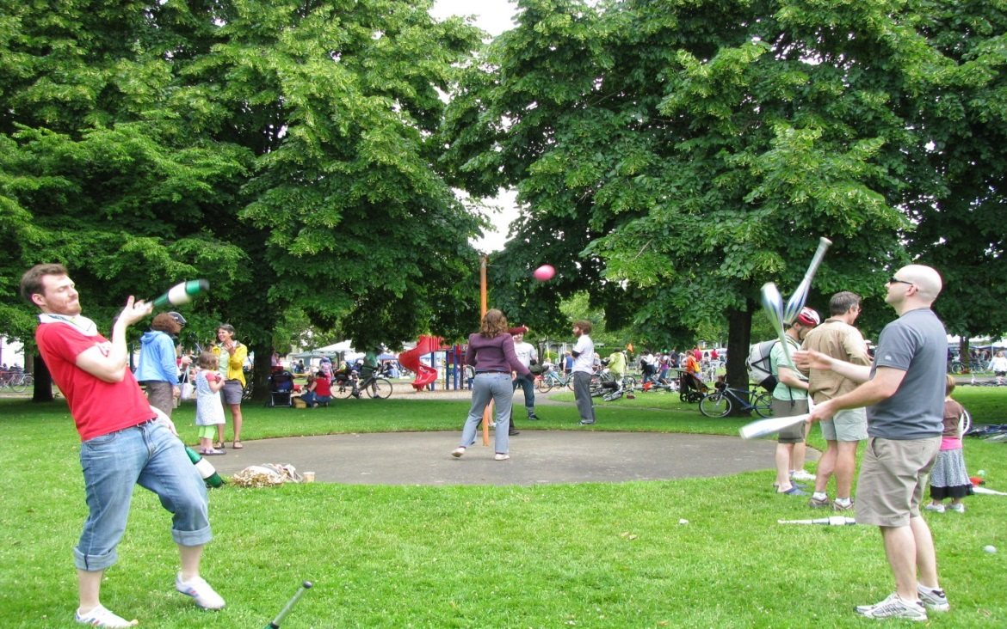

http://www.pedbikeimages.org/pubdetail.cfm?picid=1389 /Laura Sandt

OBJECTIVE 1: By [date], compile a list of parks, recreation facilities, fitness and sports clubs available to and accessible by [state/community] members, and disseminate as a resource for schools, healthcare professionals, NGOs/volunteer groups, and community members. Provide information regarding resources available at each location, as well as suggested improvements.
Activity/Strategies | Partners | Time | Cost | Indicator
Compile information about PRFS facilities and personnel; include location/accessibility, cost, safety, activities provided, and areas of deficit. | [WHO will be responsible?] | [By WHEN will this be accomplished?] | [How MUCH can you spend on this?] | Report.
Using social media and other forms of communication, disseminate findings with interested individuals and organizations. |  |  |  | Number of individuals/organizations receiving information.
Decide which geographic or social areas are not having their PRFS physical activity needs met, and alongside community members, choose 1-2 strategies to correct the problem. Implement strategies. |  |  |  | Strategies chosen.
Evaluate: Is the report comprehensive for [state/community]? Have findings been shared appropriately? Have any positive changes resulted from the community-based interventions? |  |  |  | % Information for state/community PRFS reported.  # Organizations receptive of findings  # People with increased access to PRFS opportunities.

Public Health

According to the American Public Health Association, there are three primary goals of public health:
- Prevention: Preventing disease and promoting healthy habits and good health.
- Policy Development: Advocating for evidence-based policies which promote health.
- Surveillance: Monitoring health of populations and keeping track of trends or epidemics (such as obesity).²³
The National Physical Activity plan notes the importance of public health- both as a profession and as a practice- with regards to physical activity interventions. There are several strategies offered within this sector which [name of coalition] would like to pursue.

The first strategy is to disseminate tools and resources important to promoting physical activity. In addition to this physical activity plan, the [name] coalition is working closely with the following public health [organizations/practitioners]: [list here]. This partnership will facilitate dissemination between evidence-based research on increasing physical activity and physical activity practitioners or interested individuals.

The second strategy is to monitor policies developed on the local or state-wide level, and advocate those which promote active lifestyles. [*An easy way to monitor current and past policies is through openstates.org*]. In order to advocate for policy implementation, an advocacy team including representatives from public health, the volunteer community, and concerned communities will form. This team will keep track of positive proposals, as well as advocate to keep these proposals active.^{24, 25}

Recently, there have been a number of proposed physical activity policies within [state]; these include transportation (safe routes to school, complete streets), education (before and after school physical activity programs, physical education programs), and business and industry (worksite wellness incentives). One physical activity promoting policy which we would like to highlight is the following:

[Insert recent proposed or chaptered physical activity policy here.]

In light of these strategies and of current policy activity in [state], [name of coalition] is dedicated to achieving the following objectives.

OBJECTIVE 1: By [date], form a team of physical activity policy advocates, including representation from at least three of the social sectors mentioned in the National Physical Activity Plan.
Activity/Strategies | Partners | Time | Cost | Indicator
Seek out interested representatives from various social sectors. | [WHO will be responsible?] | [By WHEN will this be accomplished?] | [How MUCH can you spend on this?] | Team formed.
Evaluate: How many sectors are represented? What is their capacity to monitor and influence policy? |  |  |  | # Sectors, # policies monitored, # policies advocated.

OBJECTIVE 2: By [date], compile a list of all current active and inactive physical activity proposals. Note sectors which have little political activity, as well as proposals which have a positive physical activity impact yet are stagnant in the legislature. Advocate for two policies with the team.
Activity/Strategies | Partners | Time | Cost | Indicator
Research proposed and recent physical activity policies. | [WHO will be responsible?] | [By WHEN will this be accomplished?] | [How MUCH can you spend on this?] | # Policies researched.
Decide which ones have the largest potential to increase physical activity in [geographic/social sector of concern]. |  |  |  | # Policies with large physical activity potential selected.
Choose an advocacy campaign [will it include the public or mass media efforts, or focus on communication with legislators?] |  |  |  | Advocacy campaign selected.
Advocate for at least two policies which increase physical activity. |  |  |  | # Policies advocated for.
Evaluate: Were the efforts to raise publicity about chosen policy successful? How many people participated in publicity campaigns? Did the legislature pass? |  |  |  | # Policies advocated for that have passed, or have received media/community attention.

OBJECTIVE 3: By [date], work with public health practitioners to disseminate the findings of two evidence-based physical activity interventions with affected sector representatives (school administration, business representatives, transportation planners, physicians, parks and recreation, etc.).
Activity/Strategies | Partners | Time | Cost | Indicator
Decide which two PA interventions are applicable to [community/state]. | [WHO will be responsible?] | [By WHEN will this be accomplished?] | [How MUCH can you spend on this?] | Interventions chosen.
Disseminate findings to affected parties. |  |  |  | # People/organizations receiving intervention information.
Evaluate: Did [coalition] reach an appropriate number of individuals/organizations? Did any organizational or individual PA practices positively change as a result of the disseminated information? |  |  |  | # Individuals/organizations changing PA policies/behaviors in order to align with intervention recommendations.

Transportation, Land Use and Community Design
One of the great transportation challenges of [community] is facilitating the transition from passive transport (transportation in a personal vehicle) to active transport (walking, biking, or including some measure of one or both).The option to use active transport depends on several factors: time and motivation, availability of a car, and community design. If a person has a car but it is safe, convenient, and pleasant to walk or bike, the likelihood of active commuting increases. Furthermore, if a person’s only option to get to work is to walk through an unsafe neighborhood to get to a bus stop, the likelihood of active transport is increased, but so is the level of unease.

Our goal, then, is to encourage people to actively transport not because they are forced to, but because they want to. In situations where passive transport is not an option, we would like to make active transport as pleasant as possible -in order to encourage more physical activity beyond when it is absolutely necessary.

There are several paths, both short-and long-term, to increasing active commuting. One is the creation of complete streets- streets that allow room for cars and busses, but also bicyclists and pedestrians. Often, bicycle and pedestrian friendly streets include a number of traffic-calming devices, such as bump-outs, changes in street color and texture, and medians. These measures calm the flow of traffic, making it safer and more convenient for active commuters to reach their destinations. ²⁶
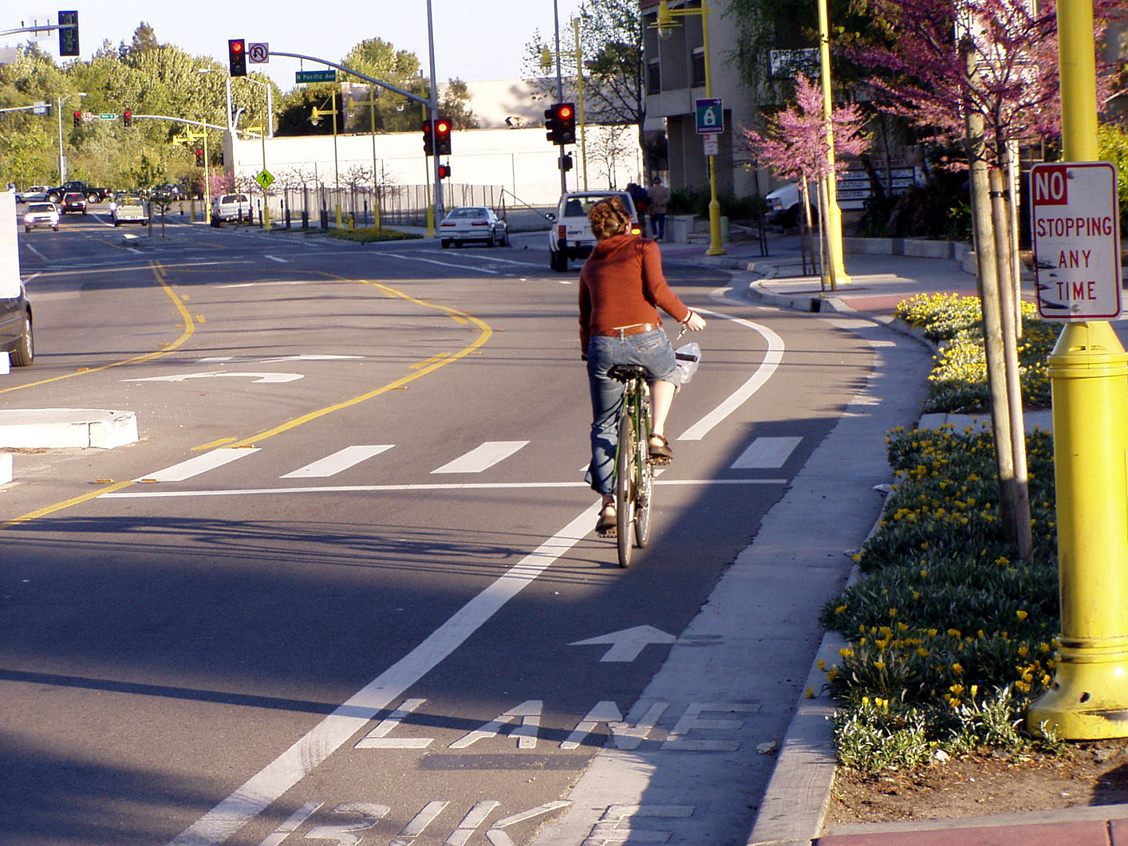

http://www.pedbikeimages.org/pubdetail.cfm?picid=790 /Dan Burden

Another evidence-based option which [name of coalition] would like to explore is the Safe Routes to School Program. This intervention ties in very nicely with educational initiatives for physical activity, as it provides children the opportunity to actively transport before and/after the school day. The program works by providing a safe passage for all or part of the route students travel to school. Safe routes can be modified to drop off students within safe walking distances, or can include the entire route, depending on distance.²⁷

A third option involves allowing pedestrians and cyclists to “take back” the streets. This initiative, called Open Streets, involves closing streets (or certain lanes) to automobiles, and allowing community members to freely walk, cycle, socialize and exercise. Such an initiative does not require major street modifications; however, it does require cooperation from [city/neighborhood] officials, local businesses, and local transportation officials.²⁸

A great deal of community layout (and thus transportation opportunities) lies at the level of policymakers. Indeed, if [name of coalition] does not support advocacy for such projects, the feasibility of any short or long-term intervention will be compromised. Specifically, such advocacy might focus on land design which increases active transport by connecting work, school, businesses, and mass transit with places of residence.

Transportation Spotlight
[Insert information on a current, recent, or proposed transportation/design intervention.
For ideas or resources see page 17.]

Our transportation, land use, and community design objectives focus on both community interventions as well as policy advocacy.

OBJECTIVE 1: Host one Open Streets event by [date].

Activity/Strategies | Partners |  | Time | Cost | Indicator
Form committee of dedicated volunteers. | [WHO will be responsible?] | [By WHEN will this be accomplished?] |  | [How MUCH can you spend on this?] | Committee formed.
Plan Open Streets, consulting the necessary governing bodies. |  |  |  |  | *Plan of action.  *Correspondence with officials.
Implement Open Streets. |  |  |  |  | Open Streets.
Evaluate: How was attendance? How well was the event marketed? How did efforts to reach out to local businesses and community members succeed? Should the event be repeated in the same place? |  |  |  |  | # Participants.  # Organizations involved.  Satisfaction ratings- participants and neighborhood organizations.  # Minutes spent physically active by all participants.

OBJECTIVE 2: By [date], form a Transportation, Land Use, and Community Design advocacy committee, which includes representation from community members, transportation designers, city planners, and local governance. Advocate for at least two policies which support Safe Routes to School, Complete Streets, or interconnectedness between work, home, and leisure time locations. Ensure that policies do not inadvertently favor historically advantaged groups.

Activity/Strategies | Partners | Time | Cost | Indicator
Form committee. | [WHO will be responsible?] | [By WHEN will this be accomplished?] | [How MUCH can you spend on this?] | Committee formed.
Decide which policies to promote. |  |  |  | Policies chosen.
Dissemination of policy information to interested community partners. |  |  |  | # Dissemination techniques used.  # People reached.
Advocate for policy with policymakers. |  |  |  | # of policymakers contacted
Evaluate: Were community members aware of the policies? Were they involved in the advocacy? Was the policy enacted? If not, what lessons were learned? |  |  |  | # Community members informed.  #Community members participating.  # Policies enacted because of committee advocacy.

Section 8: Engaging Communities in Implementation

There are many ways community members can and should be involved in the implementation of this physical activity plan. It is our goal that community members are an integral part of program planning, implementation, and evaluation.

Community participation is important because it aids in efficiency, as community members often know the behaviors of other community members better than observers or interveners. Community members often have insight into specific barriers and incentives to desired behaviors, and often can help identify unforeseen consequences. Community participation increases “buy-in” in a specific project, making it more likely members will both participate in and promote specific interventions. With this sense of ownership comes also a feeling of responsibility- and when communities feel responsible for programs, the likelihood that they are sustained is increased.²⁹
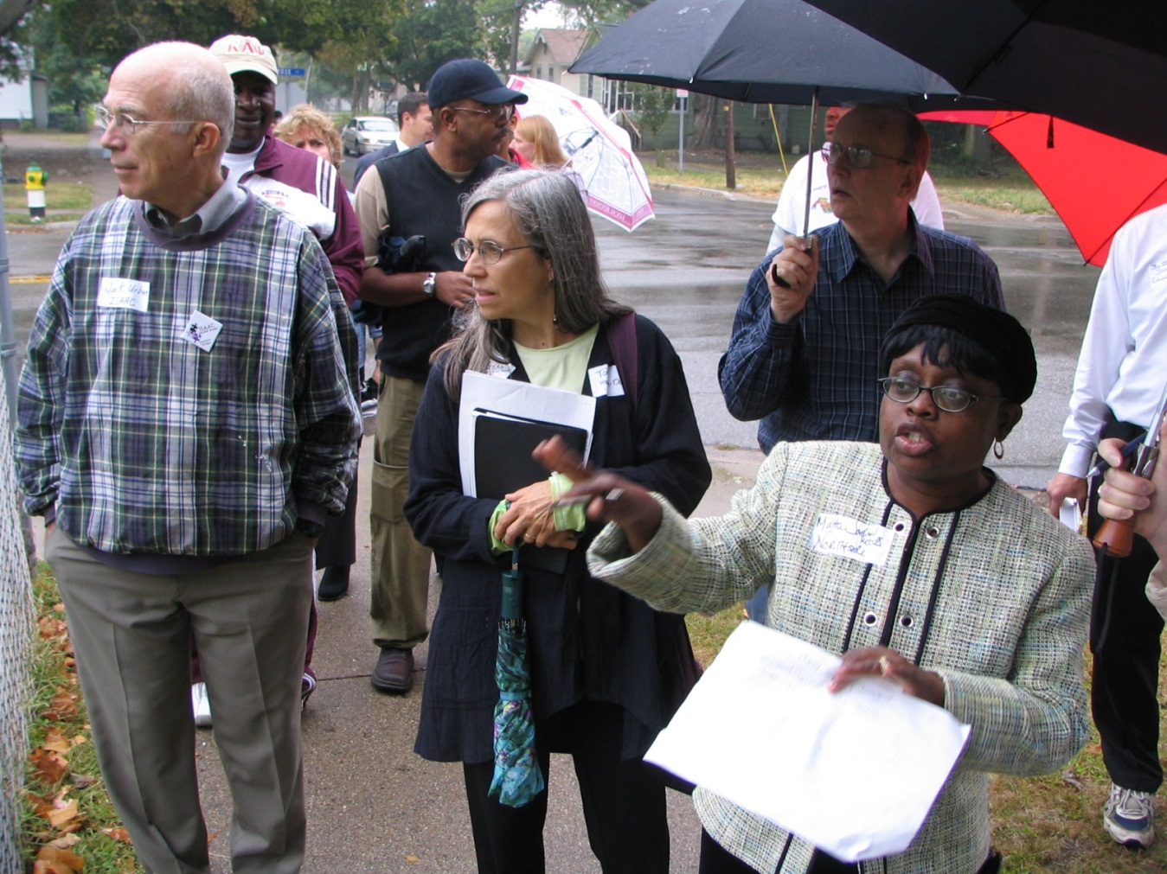
http://www.pedbikeimages.org/Burden,Dan

There are many stages and ways in which community members participated in this coalition. During the initial stage, “community assessment,” community members provided their input regarding desired physical activity improvements. Some of the findings that we found interesting were that [insert interesting findings from community participants gathered at assessment phase].

During the planning phase, community members helped form objectives, offering opinions and suggestions. We would especially like to thank [list names] for their valuable input.

Now that we are in the mobilization phase of our physical activity plan, community members have volunteered to participate through [list volunteer activities], as well as through joining one of our several policy advocate committees.

Alongside mobilization comes the commitment to participate in the implementation phase- community members have already agreed to participate in many of the proposed initiatives, including [what initiatives are community members willing to participate in?]

Finally, community members will be the “eyes and ears” of our physical activity interventions. They will be an immense help to on-the-ground monitoring and end-of-program evaluation efforts.

Without the buy-in of [community/state name] members, this Physical Activity plan would not have been created, and many of the proposed interventions would never be possible. The following is an example of how powerful community involvement has been supporting physical activity.

Community Participation Spotlight

[Include an example of an intervention/project idea that
was suggested by or will be implemented because of community participants, or a picture of your community members.]

Section 9: References
- Physical Activity and Health. Centers for Disease Control and Prevention. http://www.cdc.gov/physicalactivity/everyone/health/ Accessed 5/3/2013.
- Hu FB. Sedentary lifestyle and risk of obesity and type 2 diabetes. PubMed. 2003;382): 103-8. http://www.ncbi.nlm.nih.gov/pubmed/12733740
- The Plan. National Physical Activity Plan. http://www.physicalactivityplan.org/theplan.php Accessed 5/3/2013.
- Be Wild. Be Wonderful. Be Active: West Virginia Physical Activity Plan. Executive Summary. The WV Physical Activity Plan. http://www.wvphysicalactivity.org/documents/WV%20Physical%20Activity%20Plan%20Summary_Final.pdf. Accessed 5/3/2013.
- Facts about Physical Activity. Centers for Disease Control and Prevention. http://www.cdc.gov/physicalactivity/data/facts.html. Accessed 5/3/2013.
- CDC’s State-Based Nutrition and Physical Activity Program to Prevent Obesity and Other Chronic Diseases: Social-Ecological Model. Centers for Disease Control and Prevention. http://eclkc.ohs.acf.hhs.gov/hslc/tta-system/health/Health/health%20manager%20resources/health%20manager%20resources%20program%20staff/cdcsstatebased.htm. Accessed 5/3/2013.
- Business and Industry. National Physical Activity Plan. http://www.physicalactivityplan.org/business_st2.php
- Interventions. Healthy People 2010. http://www.healthypeople.gov/2010/Implementation/
- Fast Facts. National Center for Education Statistics. http://nces.ed.gov/fastfacts/
- Education. National Physical Activity Plan. http://www.physicalactivityplan.org/education.php
- Interventions on Diet and Physical Activity: What Works. 2009. World Health Organization. http://www.who.int/dietphysicalactivity/summary-report-09.pdf
- Health Care. National Physical Activity Plan. http://www.physicalactivityplan.org/healthcare.php
- Interventions on diet and physical activity: What works summary report. 2009. World Health Organization.http://www.who.int/dietphysicalactivity/summary-report-09.pdf
- Georgia's Nutrition & Physical Activity Strategic Plan. Georgia Department of Human Resources and Take Charge of Your Health, Georgia! http://beproactivefoundation.org/media/6a9a857bc6e14cbdffff8020ffffd523.pdf
- Indiana's Comprehensive Nutrition & Physical Activity Plan, 2010-2020. Indiana State Department of Health. http://www.inhealthyweight.org/files/IN_State_Obesity_Plan_2010-2020.pdf
- Mass Media National Physical Activity Plan. http://www.physicalactivityplan.org/media.php
- Campaigns and Informational Approaches to Increase Physical Activity: Stand-Alone Mass Media Campaigns The Community Guide. http://www.thecommunityguide.org/pa/campaigns/massmedia.html
- Global Strategy on Diet, Physical Activity and Health: Mass Media. World Health Organization. http://www.who.int/dietphysicalactivity/whatworks-media/en/index.html
- Wheeling Walks. WVU Foundation. http://wheelingwalks.org/
- Volunteer and Non-Profit. National Physical Activity Plan.
http://www.physicalactivityplan.org/volunteer.php
21. Parks, Recreation, Fitness and Sports. National Physical Activity Plan. http://www.physicalactivityplan.org/parks.php
22. Jacobs, G. Poor Neighborhoods can Harm Health. October 28, 2011. San Diego State University. http://newscenter.sdsu.edu/sdsu_newscenter/news.aspx?s=73238
23. What is Public Health. American Public Health Association. http://www.apha.org/NR/rdonlyres/C57478B8-8682-4347-8DDF-A1E24E82B919/0/what_is_PH_May1_Final.pdf
24. Public Health. National Physical Activity Plan. http://www.physicalactivityplan.org/pubhealth.php
25. Discover Politics in Your State. Sunlight Foundation. http://openstates.org/
26. National Complete Streets Coalition. Smart Growth America. http://www.smartgrowthamerica.org/complete-streets
27. Safe Routes. National Center for Safe Routes to School. http://www.saferoutesinfo.org/
28. Open Streets Project. Alliance for Biking and Walking and Street Plans. http://openstreetsproject.org/
29. Participatory Approaches to Planning Community Interventions. The Community Toolbox: University of Kansas. http://ctb.ku.edu/en/tablecontents/sub_section_main_1143.aspx

Section 10: Appendices
[Add appendices such as your logic model, surveys and various assessment tools]

